**Build and Deploy Dockerized React JS Application with AWS CI-CD and ElasticBeanstalk**

**1.Application Creation**

Create a simple maven application and create Dockerfile for that application.

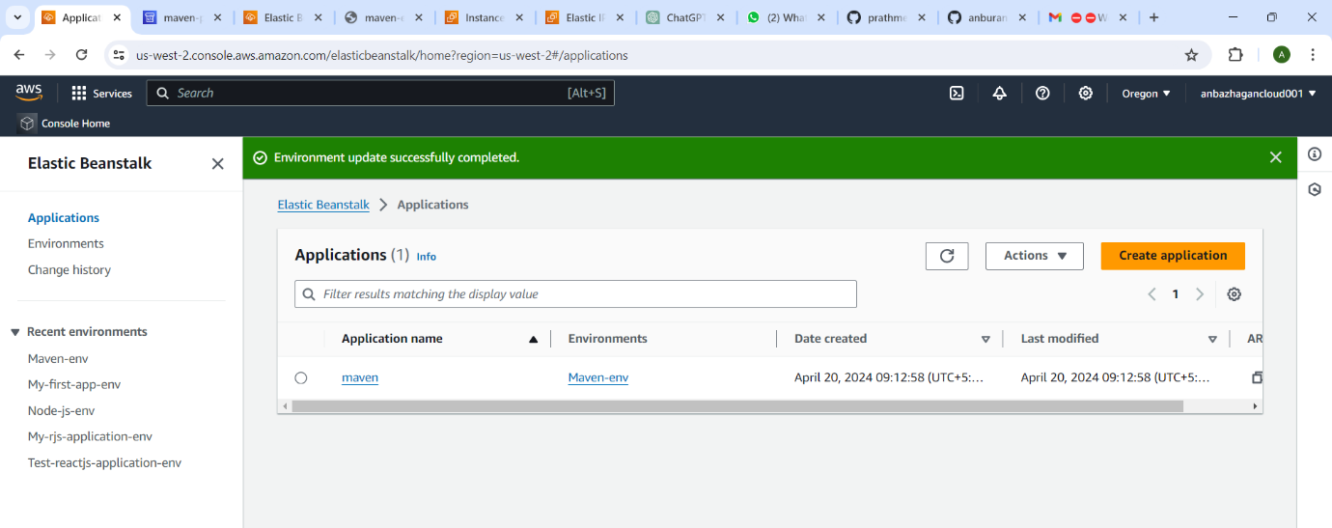

**2.Code Storage (CodeCommit)**

Create a github repository using instead of aws Codecommit

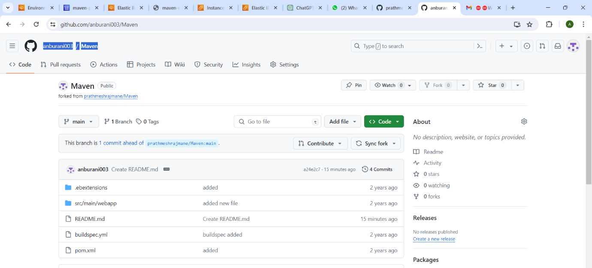

**CodeBuild**

Use CodeBuild service to build the code using

(Use buildspec.yml file).

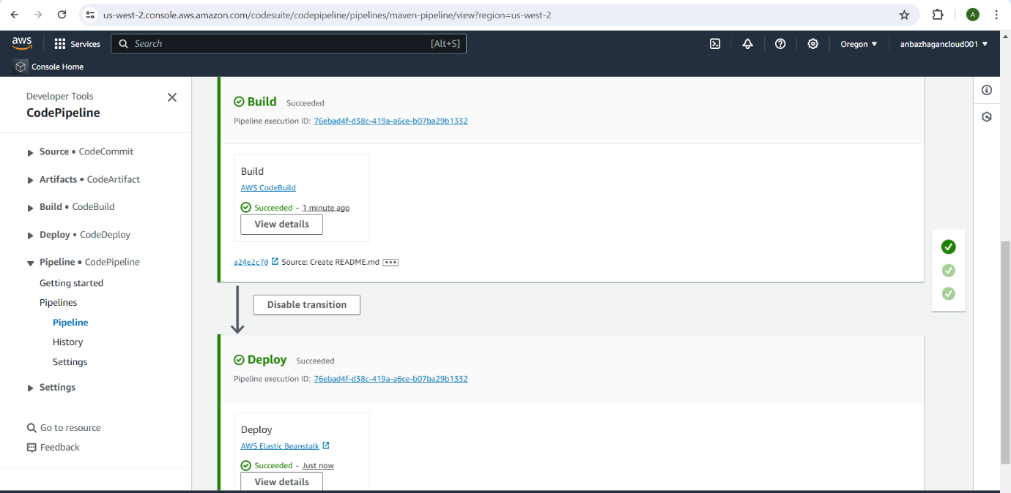

**Continuous Integration (CodePipeline)**

Create a Codepipeline and choose source as codecommit and build stage as codebuild and deploy stage as elasticbeanstalk to deploy our created maven application.

